Nadine lynch

ABET LEVEL 4

Class subject: Life orientation

Task: 1-4

Subject ID:

Student ID: 22124565

South African Id: 8912300079082

Edition: 2020/2021

Task 1 poster:

1.1: Design a poster that outlines FIVE (5) environmental problems in your community.

(Use photos in this section)

1.2: Discuss THREE (3) negative effects of EACH of the FIVE environmental problems identified in Question 1.1: (use copies of each image)

1. **Air Pollution:**
2. 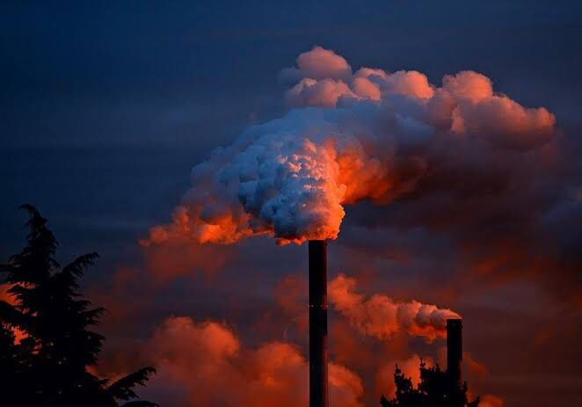Long-term health effects from air pollution include **heart disease, lung cancer, and respiratory diseases such as emphysema**. Air pollution can also cause long-term damage to people's nerves, brain, kidneys, liver, and other organs.
3. Air pollution is caused by **solid and liquid particles and certain gases that are suspended in the air**. These particles and gases can come from car and truck exhaust, factories, dust, pollen, mold spores, volcanoes, and wildfires. The solid and liquid particles suspended in our air are called aerosols.
4. This happens most commonly in large cities where emissions from many different sources are concentrated. Sometimes, mountains or tall buildings prevent air pollution from spreading out. This air pollution often **appears as a cloud making the air murky. It is called smog. The word "smog" comes from combining the words "smoke" and "fog."**
5. **Exhaust pollution: (this one I have just added a section from own of other paper that I did in past)**

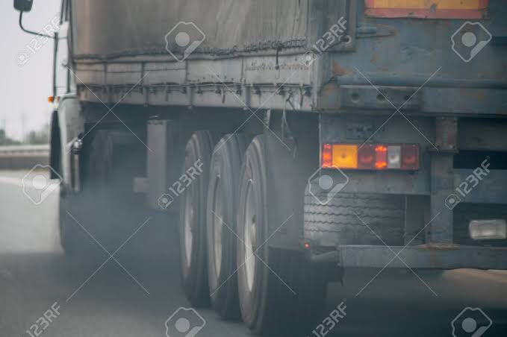

The Dangers of Exhaust Fumes to Our Environment

Combustion from fossil fuel engines such as those which burn gasoline and diesel fuel is causing irreparable damage to the environment. Carbon monoxide isn’t the only carbon by-product given off in exhaust fumes. Carbon dioxide is also a problem, and we know that it is the number one cause of the breakdown in the ozone layer which is leading to global warming. However, global warming is a catchall phrase that encompasses a great number of problems both to the earth on which we live and to the creatures that dwell on it. Without going into a treatise on global warming it should be sufficient to say that the surface of the earth is heating gradually so that the polar ice caps are melting, and growing seasons are being disrupted.

Unfortunately, this is just the beginning of a snowball effect that filters down through virtually every life form on the planet. Animal habitats are being destroyed at a record speed, which causes creatures to seek new sources of food and shelter. As a result, is projected at that some species could very well become extinct within our lifetime. Also, due to a change in the length of growing seasons many crops will become scarcer and of course, food will become much more expensive when available. The melting polar caps will cause an increase in sea level which will most certainly submerge many islands and coastal areas forcing both animals and humans farther inland.

1. **Water pollution:**
2. 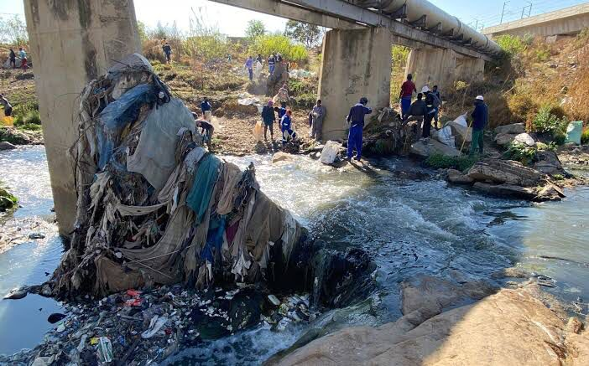Floods in low lying areas
3. No clean water for drinking
4. Hazard materials like lead and micro-plastics, harmful chemicals
5. Uranium pollution:
6. 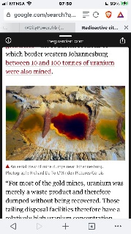G
7. H
8. G
9. 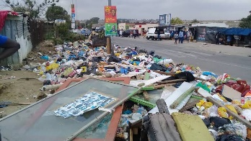Land pollution:
10. G
11. H
12. G

1.3: Outline TWO (2) solutions that address each of the FIVE (5) above-mentioned environmental problems.

1. Air pollution:
2. Exhaust pollution:
3. Water pollution:
4. Uranium pollution:
5. Land pollution:

1.4: Draw a plan of action to deal with ILLEGAL DUMPING AREAS for the current year using the table below. Identify and list THREE solutions, who should be responsible for each solution, and by when it must be done.

(well, I can’t draw but I can make a visual description of the plan)

1.5: We must protect our environment.

Mention THREE ways in which we can protect our environment.

1. Plant more trees
2. Conserve our water resources
3. Reduce the use of vehicles on our roads

Task 2:

* 1. Read the case study below and answer the questions that follow:

Sipho recently started working as an intern at a local district office. The internship is valid for 1 year and he may be offered a full-time position if he does well and impresses his supervisor. He is planning to buy a 2-bedroom house, and he is hoping to have saved enough money to put down a deposit. Sipho would like to buy and move into the house in 2 years’ time. However, he is not sure what he needs to do to ensure he achieves this goal. (own creation)

Complete the table below by providing FIVE (5) activities that Sipho will need to do to achieve his goals. Include possible time frames for when each activity should be completed:

1. Activities to be done to achieve his goal:

* O
* O
* O
* O
* O

1. Duration (time frame) needed to achieve each activity.

* D
* T
* T
* T
* T
  1. Provide FIVE reasons why using a planner as a tool for managing time is important.

1. F
2. F
3. F
4. F
5. F

ACTIVITY 2: FINANCIAL MANAGEMENT

* 1. List any FIVE (5) commercial banks in South Africa.
  2. Describe the meaning of the following financial terms in your own words:

2.2.1 Budget:

2.2.2 Interest:

2.2.3 Loan:

2.2.4 Overdraft:

2.2.5 Long-term insurance:

ACTIVITY 3: DIFFERENT BELIEFS

Different beliefs are protected in the Constitution of the Republic of South Africa. Demonstrate your understanding of the different religions by identifying FIVE (5) that are practised in South Africa and completing the table below:

1. Name of religion:

* F
* F
* F
* F
* F

1. Place of worship

* F
* F
* F
* F
* F

1. Supreme being in whom they believe
2. Task 3

ACTIVITY 1: SELF-ESTEEM AND RELATIONSHIPS

Read the case study below and answer the questions that follow:

Our self-esteem and self-awareness affect the way we approach life. If we feel good about ourselves, we are likely to be more confident in the things we do. People with low self-esteem generally lack confidence. (Own creation)

* 1. Discuss in detail FIVE (5) ways in which a person with a high self-esteem usually behaves in the workplace or in the community.
  2. 1.2 Identify THREE (3) positive experiences in your own life that may have influenced your self-esteem.
  3. List FOUR (4) ways in which negative experiences can be turned into something positive.

­­­­­­­­­­­­­­

ACTIVITY 2: HEALTH AND WORKPLACE

Read the statement below and answer the questions:

Ill-health and injuries pose a threat to sustainability as well as competitiveness in the workplace. As a result, businesses and companies suffer additional costs. (Own creation)

2.1 Explain FIVE rights of people living with incurable diseases as stated in the South African Constitution.

2.2 Discuss FIVE ways in which ill-health or injuries may impact negatively on businesses and companies.

2.3 State TEN methods for coping with HIV/AIDS infections.

Task 4

ACTIVITY 1: HEALTHY LIVING

Study the case study below and record your journal entry by responding to the following questions:

Stars like David Beckham, who advertise fizzy drinks, chocolate bars and chips have been blamed for making children fat. In South Africa, former Springbok rugby captain Francois Pienaar promotes a brand of chips. Children everywhere these days are becoming more and more overweight. They are also getting diseases associated with being overweight, such as diabetes.

* 1. List any FIVE (5) examples of junk food that you know of.
  2. Provide FIVE (5) possible reasons why people buy junk food.
  3. Discuss FIVE disadvantages of eating junk food
  4. Describe how the following factors can influence a person’s choice of food:

1.4.1. Cultural factors

1.4.2. Religious factors

1.4.3. Economic factors

1.4.4. Social factors

1.4.5. Political factors

­­­­­­­­­­­­­­­­

ACTIVITY 2: VITAMINS AND MINERALS

2.1 The table below lists FIVE (5) diseases caused by malnutrition.

Complete the table by listing TWO (2) symptoms of each disease and the name of the deficient mineral or nutrient that causes the disease:

|  |  |  |
| --- | --- | --- |
| Diseases/condition | State TWO signs/symptoms | Deficient nutrient/mineral |
| Rickets |  |  |
| Anaemia |  |  |
| Scurvy |  |  |
| Pellagra |  |  |
| Kwashiorkor |  |  |

* 1. Identify FIVE (5) personal hygiene activities associated with healthy living.

Task 5:

QUESTION 1

Various options are given as possible answers to the following questions.

Choose the correct answer and encircle only the letter (A–D).

1.1 An old person who sexually predates on young children is known as a

__________________.

1. Xenophobia.
2. Heterosexual.
3. Homosexual.
4. Pedophile.

(1)

1.2 Many people are not working due to a high ________________ rate.

1. loafing
2. leisure
3. unemployment
4. HIV

1.3 Mantwa is a medical doctor while Eunice, her sister, is responsible for animal health. Eunice is a/an ___________.

1. Gynecologist.
2. Veterinarian.
3. Urologist.
4. Pediatrician.

1.4 The recommended maternity leave for working mothers is ________ months.

1. 6
2. 1
3. 3
4. 4

(1)

1.5 People who are addicted to drugs are placed in a ___________.

1. rehabilitation centre.
2. house of safety.
3. home-based care centre.
4. community hall.

QUESTION 2

Choose a description from COLUMN B that matches a word in COLUMN A. Write only the correct letter (A–E) in the table provided below.

1. Childminder
2. Self-esteem
3. Entrepreneur
4. Herbalist
5. Nicotine

Answer

1. Addictive drug in cigarettes.
2. A person who grows or sells herbs for medical use
3. Lends money and charges high interest.
4. A person who looks after children in a daycare centre.
5. E Mary is self-employed.
6. Zandile believes in herself

QUESTION 3

Indicate whether the following statements are TRUE or FALSE. Choose the correct answer and write only 'TRUE' or 'FALSE' next to the question number (3.1–3.5)

3.1 Physically disabled people do not participate in sports.

3.2 There are eight official languages in South Africa.

3.3 Inter-racial marriage is allowed in South Africa.

3.4 HIV/AIDS can be transmitted through unprotected sex with an infected

person.

3.5 Being healthy means that one can do without food.

QUESTION 4

Write the following abbreviations in full:

4.1 SAQA

4.2 SAFA

4.3 MTCT

4.4 CEO

4.5 NQF

SECTION B

QUESTION 5: PERSONAL FITNESS

Helictical development should be our main focus at all times. It includes body, mind, and spirit.

* 1. Describe THREE (3) ways in which one can be physically fit.
  2. Describe TWO (2) ways which can promote mental health.

QUESTION 6: HEALTH LIVING

6.1 Complete the following table by writing ONE (1) source of nutrients/type of food and ONE (1) function of each nutrient in the human body:

|  |  |  |
| --- | --- | --- |
| Nutrients | Source of nutrients/type of  food | Function of the nutrient  in the human body |
| Vitamins and minerals |  |  |
| Protein |  |  |
| Sugar |  |  |

6.2 Discuss FOUR (4) results of eating unhealthy food.

QUESTION 7: SELF – KNOWLEDGE

7.1 Discuss FIVE (5) ways that can assist a person to know himself or herself.

7.2 Explain THREE (3) instances in which a person feels positive about his or her life

7.3 Identify TWO reasons a person can feel negative about his or her life.

This is the sheet I have created is for some of the answers that I cannot put on paper, is it may be more than 1-1 $\frac{1}{2}$ pages. I have also added an assignment that I have done at an online university.

Down here is the paper from when I did Environmental sciences (elective) program

Student’s name: Nadine Lynch

[This Photo](https://southafricatoday.net/environment/worlds-biggest-trade-deal-in-trouble-over-eu-anger-at-brazil-deforestation/) by Unknown Author is licensed under [CC BY-ND](https://creativecommons.org/licenses/by-nd/3.0/)

Professor’s/ Instructor’s name: [Robert James (Instructor)](https://my.uopeople.edu/user/view.php?id=19490&course=3614)

Course: ENVS 1301: INTRODUCTION TO ENVIRONMENTAL SCIENCES(the full name of the course)

Date: 10 April 2020 (When I was studying)

School: University of the people ([www.uopeople.edu](http://www.uopeople.edu))

**AFRICA**

**What environmental concerns in your local area did you learn about?**

**[1]Deforestation:** Deforestation has become one of the major factors, which is affecting the ecological balance of not only Africa, but of the entire world. The clearing of forest cover for wood and agricultural land has resulted in soil erosion, climate change, less rainfall, and many other adverse conditions. Degradation in the quality of soil and loss of fertility has also become a very serious concern. Although the government has taken initiative for growing more plants, the imbalance in nature cannot be covered by just a little effort.

**Air Pollution:** Though the countries of this continent do not contribute much to the world air pollution, the increasing population has shown an increase in the air pollution as well. This may be due to the industries, which are set up in the parts of countries where labor is easily available. Also, there are many houses where the food is still cooked by burning wood and coal. This too, contributes to air pollution.

**Water Pollution:** Water pollution is among the top problems. Africa accepts solid waste from the developed countries like America, European countries and Japan for which they get paid. But these solid wastes are not processed properly, and are dumped in the rivers and other water bodies. This results in water pollution. Human waste has also contaminated the water bodies and access to fresh and clean water has become very difficult**.**

**Energy:** The major source of energy here is wood. 70% of the energy is generated by burning coal and wood, which results in deforestation, soil erosion, air pollution, and ecological imbalance. The government has started awakening people and has made many efforts to get the conditions under control. An alternate energy source will require money and the continent is not so strong financially, so, this may take a while.

**Loss of Biodiversity:** Africa has many endangered species of flora and fauna. But due to the deforestation and the need of land for agriculture, there is a huge loss of biodiversity. The uneducated and tribal people are still dependent on hunting. Many of them burn up lands and forests in order to find animals easily. This has led to the death of many other animals too.

**Oil Pollution:** Oil is one of the major sources of income for these countries, but this has raised many environmental issues, which are very difficult to overcome. The advanced technology used to get oil is very dangerous and hazardous for the environment. But due to the lack of education and lack of proper rules, the extraction of oil is done through the same methods. The transportation of oil through the sea route has also polluted the sea water due to improper packaging and transport.

1. **Did they surprise you? Why or why not?**

Yes they surprised me, the reason why is because I have seen how our climate has chanced over the years and our environment has declined, we have people littering and that litter is landing in our oceans that is called water pollution, they are made of small pieces of plastic, oil spills from what I understand and remember that those tiny piece of plastic get eaten by our fish, our fish gets eaten by birds, dolphins, seals, then we eat the fish, and oil spills are harmful all sea life, from penguins, birds, whales, fish, dolphins and all the other animals that live in the ocean. Don’t forget about the melting of our polar caps that is cause by Global Warming.

1. **What do you think can be done to improve this (these) situation(s), hazard(s), problem(s), or concern(s)?**

I think we need to try and stop littering and try make our oil ships unsinkable meaning make them strong enough to withstand a collision on rocks or prevent the worker on the ships from dumping the oil barrels overboard into the ocean below.

1. **Give two interesting facts that you learned about your country from the Environmental Snapshots page at the UN Statistics Division link.**

***South Africa***

[2]I choose the two following interesting facts that I have learned from the environmental snapshots page at the UN statistics division link for South Africa

**1) Biodiversity:**

|  |  |  |
| --- | --- | --- |
| Proportion of terrestrial and marine areas protected (%) | 10 | Year: 2014 |
| Number of threatened species | 570 | Year: 2015 |
| Fish catch (tons) | 609 513 | Year: 2014 |
| Change in fish catch from the previous years (%) | 29 | Year: 2014 |

**2) Economy**

|  |  |  |
| --- | --- | --- |
| GDP growth rate from previous years (%) | 2 | Year: 2014 |
| GDP per Capita at current prices ($US) | 6482 | Year: 2014 |
| % Value added: agriculture, hunting, forestry, fishing | 2 | Year: 2015 |
| % Value added: mining, manufacturing, utilities | 25 | Year: 2015 |

2020: the economic has been downgraded to “junk” status due to a rating agency called Moody’s moved SA into “junk” status on March 27, 2020

1. **What other thoughts would you contribute to the topic?**

I would like to see the updated version of given website as I think most of these numbers have either risen or declined since the last time it was calculated.

I would like to show you the differences between the SO2 emissions I have chosen South Africa and United states of America;

**[3]South Africa: SO2 -sulfur dioxide**

|  |  |  |
| --- | --- | --- |
| SO2 (1000t) | N/A | N/A |
| SO2 per Capita (kg) | N/A | N/A |

**[4]USA: SO2 -sulfur dioxide**

|  |  |  |
| --- | --- | --- |
| SO2 (1000t) | 43739 | Year: 2012 |
| SO2 per Capita (kg) | 15 | Year: 2012 |

As you can see in my example of the SO2 emissions in both countries, one is nonexistent and the other one exists.

**References**

[**https://helpsavenature.com/environmental-issues-in-africa**](https://helpsavenature.com/environmental-issues-in-africa)

[**https://unstats.un.org/unsd/environment/envpdf/Country_Snapshots_Dec_2016/South%20Africa.pdf**](https://unstats.un.org/unsd/environment/envpdf/Country_Snapshots_Dec_2016/South%20Africa.pdf)

[**https://unstats.un.org/unsd/environment/envpdf/Country_Snapshots_Dec_2016/South%20Africa.pdf**](https://unstats.un.org/unsd/environment/envpdf/Country_Snapshots_Dec_2016/South%20Africa.pdf)

[**https://unstats.un.org/unsd/environment/envpdf/Country_Snapshots_Dec_2016/United%20States%20of%20America.pdf**](https://unstats.un.org/unsd/environment/envpdf/Country_Snapshots_Dec_2016/United%20States%20of%20America.pdf)

1. <https://helpsavenature.com/environmental-issues-in-africa>
2. <https://unstats.un.org/unsd/environment/envpdf/Country_Snapshots_Dec_2016/South%20Africa.pdf>
3. <https://unstats.un.org/unsd/environment/envpdf/Country_Snapshots_Dec_2016/South%20Africa.pdf>
4. <https://unstats.un.org/unsd/environment/envpdf/Country_Snapshots_Dec_2016/United%20States%20of%20America.pdf>